**Carolina de Miranda**

Project Leader Peru / Fundación Capital

**Bio**

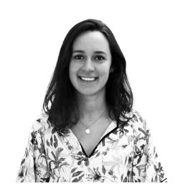Carolina de Miranda works as Project Leader - Peru at Fundación Capital, where she develops projects related to financial inclusion and livelihood promotion for people living in poverty. Carolina is an expert on social protection, particularly poverty reduction policies and women’s empowerment. Before coming to Fundación Capital, she worked on projects for youth entrepreneurs and the use of ICTs in education. She holds a MA in development studies from the Institute of Development Studies UK and a graduate diploma in socio-environmental management. She has worked in Peru, Brazil, Mexico and UK.

**Maria Antonia Hoyos Gutiérrez**

Director of Research and Digital Solutions / Fundación Capital

**Bio**

****As director of digital solutions at Fundación Capital, María Antonia Hoyos heads the department of digital solutions. María Antonia has experience in entrepreneurship, social investment and information and communication technology. Before coming to Fundación Capital, María Antonia was director of business expansion for Colombia, Peru and Mexico at Afluenta, a FinTech platform. She holds a degree in government, finance and international relations and a specialization in financial administration.

**Mauricio Romero**

Research and Evaluation / Fundación Capital

**Bio**

Mauricio Romero heads project evaluation and research for developing new products and initiatives with a social impact in different Latin American and Caribbean countries. He has experience in various research methodologies. His areas of interest include financial and productive inclusion, economic citizenship and socioeconomic development. Mauricio has extensive experience in marketing and advertising research and specializes in qualitative methodologies, consumer behavior, communications and shopper studies. He studied social anthropology and has a graduate diploma in non-profit business management. He also has experience as a graduate professor, lecturing on qualitative research and analysis of low-income consumer behavior.